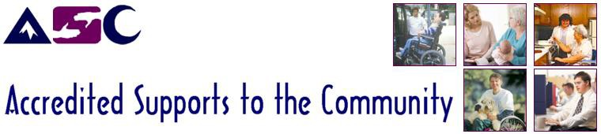
Operating for over 49 years, Accredited Supports to the Community (ASC) is a not-for-profit charitable society that provides Level Two Accredited Services for adults with disabilities.

Full Time - Olds
Team Manager

This is a leadership position working within and managing hourly Supported Independent Living Services (Outreach) and Employment Services for adults with disabilities; which includes supports in community access, inclusion, social connection, life skills; pre-employment preparation, employment as well as personal and medical supports. In this position you will make a direct impact in the lives of others and strive for a stimulating career where you will make a meaningful difference. Starting wage $24.95.

Key aspects of this role include:
- Providing leadership, supervision, and evaluation to direct support staff while planning and implementing according to individual and program needs. This includes schedule development, monitoring, and providing direct coverage as required.
- Monitoring and managing service delivery; participating in the development and monitoring of client service and support plans with a person-first approach.
- Actively engaging and mentoring support staff to model behaviour aligned with the culture, values, policies and procedures of Accredited Supports to the Community. Communicate and gather information effectively in a variety of settings including one-on-one with staff and in team meetings.
- Committing to providing an exceptional experience for staff and clients within a challenging and exciting human services environment by setting the example of high quality, client-focused care.

The choice candidate will have:
- A minimum of 3 years previous leadership and supervisory experience, preferably in disability services, however other experience will be considered.
- Post-secondary education, or experience working, in the Human Services Industry.
- Well-developed leadership, coaching and mentoring skills; an ability to communicate effectively with others; strong problem-solving skills; and experience supporting persons with developmental disabilities to live engaged in their communities.
- Experience with FASD, mental health and Positive Behavior Supports is an asset.
- Experience with computers including Microsoft Word, Excel, and Outlook.

Requirements:
- Class 5 driver’s license and required vehicle insurance coverage ($2million liability insurance).
- Current and clear Vulnerable Sector Criminal Record Check
- Ability to be flexible to work a variety of shifts including overnights and some evenings and weekends as required; meeting the needs of the people served and our programs.
Why Choose ASC?
- A rewarding career with potential for advancement
- Flexible hours, EFAP, Extended Benefits, and optional Employer/Employee RRSP
- Supportive work environment
- Ongoing professional training and development

Please submit the required cover letter and resume to Competition # TM0302 to hr@asc-mva.ab.ca

This position will remain open until a suitable candidate is found

